DBMS PROJECT SYNOPSIS
ON
FLYHIGH AIRLINES

Submitted by:
Aditi Bhardwaj (14103108)
Nikita Jain (14103010)
Prateek Agarwal (14103028)
Simran Chhabra (14103020)

Index
- Introduction
- General overview
- Objectives

- Design
- EER Diagram
Tables used and their attributes
- Conclusion
- Bibliography

Acknowledgement

This project consumed huge amount of work and dedication. Still, implementation would not have been possible if we did not had the support of many individuals. Therefore we would like to extend our sincere gratitude to all of them.
First of all we are thankful to Kashav Ajmera Sir for their logistical support and for providing necessary guidance concerning projects implementation.
We are also grateful to our seniors. Without their superior knowledge and experience, the Project would lack in quality of outcomes, and thus their support has been essential.
Nevertheless, we express our gratitude towards our batch mates for their kind co-operation and encouragement which help us in completion of this project.

Certificate

I Mr. Kashav Ajmera hereby certify that the student of Jaypee Institute of Information Technology of 3rd Semester nd has completed the Project FlyHigh Airlines Online Ticket Booking in the academic year 2015-2016.They have worked under my guidance and supervision.

Mr. Kashav Ajmera
______________

Introduction
General Overview
Our website has various kinds of information that helps regarding booking of tickets via airlines.

User can sign up or login and after login they can also modify their details.

Users will be able to search the airplane availability and availability in respective classes in airplane, the arrival and departure time of the airplane and they can also book the ticket and after booking the ticket if the user wants to cancel it then they can easily do it also. More ever they can also check their status .

Objectives
The objective of the online airline ticket reservation system Project is to design software to fully automate the process of issuing a airline ticket. That is:
1. To create a database of the airplane.
2. To search the airplane it’s arrival and departure time.
3. To check the availability of the ticket in airplane and respective class.
4. To book the ticket.
5. To cancel the ticket if necessary.
6. To check the status.
7. To create user database this after login can be modified by the respective user.

Current business activities
FlyHigh Airlines is operating on spot airline reservation, flight booking services with help of several travel agencies. It’s not only causing inconvenience for customers but also raises the actual tariff that customer has to pay. Though having branches in multiple cities targeting high range of customers, employee something fails to satisfy customers in remote areas when they have to travel for reservation also when they need to travel for cancellation or flight day extension. Followings are the key operations of FlyHigh Airlines day to day business:
- Sales Transactions
All sales transactions are related to flight ticket sales; advance reservations, reservation cancellations etc.
a. Reservation
FlyHigh Airlines provides flight pre-reservation to its customers. All customers are open to reserve flights to travel in future. Reservations are taken before 11 hour of flight. Pre-reservation insuring future sales forecast.
b.Cancellation
No hard rules, as far as company does not have to lose anything. A customer is always can cancel their flights. Cancelled seats are released for re-sell instantly.Company denies canceling a sold ticket, if cancellation request is made within 6 hour of flight.

- Flight scheduling
Day to day flight scheduling, new flight arrangements according to sales potentiality, flight departure delay decisions all takes rooms in its daily flight scheduling activities etc.

- Ticketing
On spot ticket sales, online reservation sales, urgent sales, VVIP ticketing is done in its several branches, authorized agents from different travel agencies.

Database Design for Airline Reservation

Entities & their relevant attributes

Entity list
- AirCrafts
- Route
- AirFare
- Flight_Schedule
- Discounts
- Charges
- Countries
- State
- Contact_Details
- Passengers
- Branches
- Employee
- Transactions

Entity structures with relevant attributes:
AirCrafts
Field | DataType | Description | Constraints
AcID | INT | Field will store unique row number. | Primary Key
AcNumber | Varchar(32) | Aircraft number that identifies the plane. | NOT ULL
Capacity | INT | No. of seats available. | NOT NULL
MfdBy | Varchar(128) | Manufacturing company. | NOT NULL
MfdOn | DATETIME | Manufactured date of aircraft. | NOT NULL

Route
Field | Data Type | Description | Constraints
RtID | INT | Stores unique row id. | Primary Key
Airport | Varchar(32) | From where the flight will take off. | NOT NULL
Destination | Varchar (32) | Flight destinations. | NOT NULL
RouteCode | Varchar(16) | A unique Route code generated using Source & Destination of flight. | NOT NULL  UNIQUE

AirFare
Field | Data Type | Description | Constraints
AfID | INT | Stores unique row id. | Primary Key
Route | INT | Route id from Route table. | Foreign Key
Fare | Currency | Stores service charge amount. | NOT NULL
FSC | Currency | Stores fuel surcharge amount. | NOT NULL

Flight_Schedule
Field | Data Type | Description | Constraints
FlID | INT | Unique number to identify the flight. | Primary Key
FlightDate | DATETIME | Date of flight. | NOT NULL
Departure | DATETIME | Stores the departure time of flight.
Arrival | DATETIME | Stores the arrival time of flight on destination.
AirCraft | INT | Aircraft number that will fly, a number from Aircraft table. | Foreign Key
NetFare | INT | To determine total fare of flight, an ID from Air_Fare table. | Foreign Key

Discounts
Field | Data Type | Description | Constraints
DiID | INT | Unique row id. | Primary Key
Title | Varchar(32) | Label to know discount. | NOT NULL
Amount | INT | Discount amount in % | NOT NULL
Description | Varchar(255) | Discount remarks & details.

Charges
Field | Data Type | Description | Constraints
ChID | INT | Unique row id. | Primary Key
Title | Varchar(32) | Label for charge. | NOT NULL
Amount | INT | Amount of charge in %. | NOT NULL
Description | Varchar(255) | Describe cause of charge.

Countries
Field | Data Type | Description | Constraints
CtID | INT | Unique row id. | Primary Key
CountryName | Varchar(32) | Room to store country name | NOT NULL

State
Field | Data Type | Description | Constraints
StID | INT | Unique row id. | Primary Key
StateName | Varchar(32) | State name will take place here.
Country | INT | PK from Country table. | Foreign Key

Contact_Details
Field | Data Type | Description | Constraints
CnID | INT | Unique row id. | Primary Key
Email | Varchar(16) | Passenger’s contact email for transaction about flights. | NOT NULL
Cell | Varchar(16) | Passenger’s contact cell no for transaction about flights. | NOT NULL
Tel | Varchar(16) | Passenger’s contact telephone no. for transaction about flights.
Street | Varchar(64) | Street address of the passengers. | NOT NULL
State | INT | PK from State table. | Foreign Key

Passengers
Field | Data Type | Description | Constraints
PsID | INT | Unique row id. | Primary Key
Name | Varchar(32) | Passenger’s name | NOT NULL
Address | Varchar (64) | Passenger’s address | NOT NULL
Age | INT | Passenger’s age | NOT NULL
Nationalities | Varchar (16) | Nationality of the passenger. | NOT NULL
Contacts | INT | ContactID from Contact_Details table. | Foreign Key

Branches
Field | Data Type | Description | Constraints
BrID | INT | Unique id for each branches | Primary Key
Center | Varchar(16) | Branch Title | NOT NULL
Address | Varchar(32) | Address of the branch | NOT NULL
State | INT | State ID from state table | Foreign Key

Employees
Field | Data Type | Description | Constraints
EmpID | INT | Unique number to identity employee, unique on entire system. | Primary Key
Name | Varchar(32) | Employee name | NOT NULL
Address | Varchar(32) | Employee address | NOT NULL
Branch | INT | Associated branch id from Branch Table | Foreign Key
Designation | Varchar(32) | Working duty position. | NOT NULL
Email | Varchar(32) | Contact email of the employee | NOT NULL
Tel | Varchar(16) | Contact telephone number.
Ext | INT | Ext number of employee cabinet, if applicable.

Transactions
Field | Data Type | Description | Constraints
TsID | INT | Unique row id | Primary Key
BookingDate | Date/Time | Keeps the booking date. | NOT NULL
DepartureDate | Date/Time | Keeps the departure date. | NOT NULL
Passenger | INT | Transaction creator passengers row id to associate booking/cancellation, payments etc. | Foreign Key
Flight | INT | Flight no, a PK of Flight_Schedule to determine flying details & costs. | Foreign Key
Type | BIT | Reservation/Cancellation | NOT NULL
Employee | INT | Reservation agent, a row id of employee who helps the passenger to make transaction. | Foreign Key
Charges | INT | If transaction is cancellation, charges may apply as per business rules. | Foreign Key
Discount | INT | Discount offers may apply based on scheme criteria. | Foreign Key
Total | INT | Calculated value of actual payable cost by customer to make a transaction. | NOT NULL

Primary Keys & Foreign Keys
SN | Table | Primary Key | Foreign Keys
SN | Table | Primary Key | Column | References
1 | AirCraft | AcID | - | -
2 | Flight_Schedule | FlID | AirCraft | AirCraft.AcID
2 | Flight_Schedule | FlID | Route | Route.RtID
2 | Flight_Schedule | FlID | AirFare | AirFare.AfID
3 | Route | RtID | - | -
4 | AirFare | AfID | Route | Route.RtID
5 | Discounts | DiID | - | -
6 | Charges | ChID | - | -
7 | Passengers | PsID | Contacts | Contact_Details.CnID
8 | Contact_Details | CnID | State | State.StID
9 | State | StID | Country | Country.CtID
10 | Country | CtID | - | -
11 | Transaction | TsID | Passenger | Passengers.PsID
11 | Transaction | TsID | Flight | Flight_Schedule.FlID
11 | Transaction | TsID | Employee | Employee.EmpID
11 | Transaction | TsID | Charge | Charges.ChID
11 | Transaction | TsID | Discount | Discounts.DiID
12 | Employee | EmpID | Branch | Branch.BrID
13 | Branch | BrID

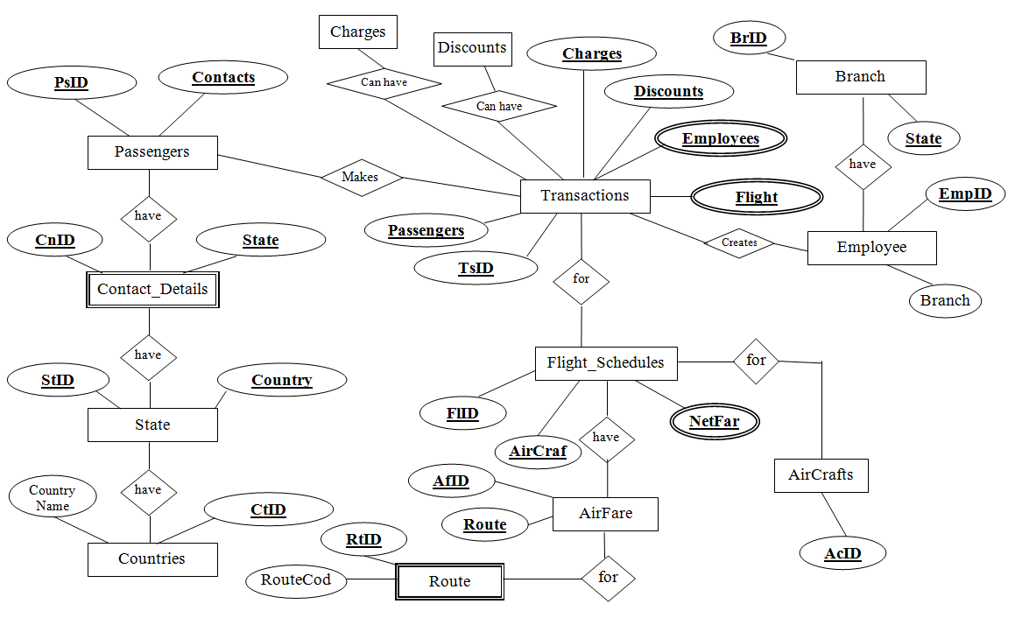

Conclusion
Achievements
The following achievements were and will be made during the project:

- We had the opportunity to learn a new technology.
- We learned to handle a project efficiently and correctly.
- Learned to tackle various adverse situations while managing and developing software.
- Learning about the functioning of the IT industry and work ethics in the corporate world.
- Learning to work with MS SQL Server 2005.
- Learning about the different phases of software development and the software engineering processes involved in the development of software.

Bibliography
Website
- Dynamicdrive.com
- W3schools.com
- Google.co.in

Books
- Shamkant B. Nawathe
- Christopher Schmitt

And other seniors and teachers.

